**Exp-2 (Implict and explicit)**

* **MainActivity.java**

package com.ad.implicit_explicit;  
  
import androidx.appcompat.app.AppCompatActivity;  
import android.content.Intent;  
import android.net.Uri;  
import android.os.Bundle;  
import android.view.View;  
import android.widget.Button;  
import android.widget.EditText;  
  
public class MainActivity extends AppCompatActivity {  
  
 @Override  
 protected void onCreate(Bundle savedInstanceState) {  
  
 EditText editText;  
 Button button;  
  
 super.onCreate(savedInstanceState);  
 setContentView(R.layout.main);  
  
 button = findViewById(R.id.button);  
  
 button.setOnClickListener(new View.OnClickListener() {  
 @Override  
 public void onClick(View view) {  
 Intent intent = new Intent(MainActivity.this, Implicit.class);  
 startActivity(intent);  
 // Explicit Intent because jumping from one activity to another  
 }  
 });  
 }  
}

* **Implicit.java**

package com.ad.implicit_explicit;  
  
import androidx.appcompat.app.AppCompatActivity;  
import android.content.Intent;  
import android.net.Uri;  
import android.os.Bundle;  
import android.view.View;  
import android.widget.Button;  
import android.widget.EditText;  
  
public class Implicit extends AppCompatActivity {  
  
 @Override  
 protected void onCreate(Bundle savedInstanceState) {  
  
 EditText editText;  
 Button button, but2;  
  
 super.onCreate(savedInstanceState);  
 setContentView(R.layout.implicit);  
  
 button = findViewById(R.id.btn);  
 editText = (EditText) findViewById(R.id.editText);  
 but2 = findViewById(R.id.button2);  
  
 but2.setOnClickListener(new View.OnClickListener() {  
 @Override  
 public void onClick(View view) {  
 // Explicit Intent because jumping from one activity to another  
 Intent intent = new Intent(Implicit.this, MainActivity.class);  
 startActivity(intent);  
 }  
 });  
  
 button.setOnClickListener(new View.OnClickListener() {  
 @Override  
 public void onClick(View view) {  
 // Implicit Intent because action from another app component without specifying the exact component  
 String url= editText.getText().toString();  
 Intent intent = new Intent(Intent.ACTION_VIEW, Uri.parse(url));  
 startActivity(intent);  
 }  
 });  
 }  
}

* **Implicit.xml**

<?xml version="1.0" encoding="utf-8"?>  
<androidx.constraintlayout.widget.ConstraintLayout xmlns:android="http://schemas.android.com/apk/res/android"  
 xmlns:app="http://schemas.android.com/apk/res-auto"  
 xmlns:tools="http://schemas.android.com/tools"  
 android:layout_width="match_parent"  
 android:layout_height="match_parent"  
 android:background="@color/white"  
  
 android:padding="10dp"  
 tools:context=".Implicit">  
  
 <Button  
 android:id="@+id/button2"  
 android:layout_width="wrap_content"  
 android:layout_height="wrap_content"  
 android:text="Go to Explicit Activity"  
 app:layout_constraintBottom_toBottomOf="parent"  
 app:layout_constraintEnd_toEndOf="parent"  
 app:layout_constraintHorizontal_bias="1.0"  
 app:layout_constraintStart_toStartOf="parent"  
 app:layout_constraintTop_toTopOf="parent"  
 app:layout_constraintVertical_bias="0.971" />  
  
 <EditText  
 android:id="@+id/editText"  
 android:layout_width="match_parent"  
 android:layout_height="50sp"  
 android:autofillHints=""  
 android:hint="Enter Data"  
 android:padding="10dp"  
 android:background="@drawable/edit_back"  
 app:layout_constraintBottom_toTopOf="@+id/btn"  
 app:layout_constraintEnd_toEndOf="parent"  
 app:layout_constraintHorizontal_bias="0.5"  
 app:layout_constraintStart_toStartOf="parent"  
 app:layout_constraintTop_toBottomOf="@+id/textView"  
 app:layout_constraintVertical_bias="0.5" />  
  
 <Button  
 android:id="@+id/btn"  
 android:layout_width="wrap_content"  
 android:layout_height="wrap_content"  
 android:onClick="search"  
 android:text="Search"  
 app:layout_constraintBottom_toBottomOf="parent"  
 app:layout_constraintEnd_toEndOf="parent"  
 app:layout_constraintStart_toStartOf="parent"  
 app:layout_constraintTop_toBottomOf="@+id/editText"  
 app:layout_constraintVertical_bias="0.5" />  
  
 <TextView  
 android:id="@+id/textView"  
 android:layout_width="wrap_content"  
 android:layout_height="wrap_content"  
 android:text="Implicit Intent"  
 android:fontFamily="sans-serif-light"  
 android:textSize="25dp"  
 android:textStyle="bold"  
 android:textColor="@color/black"  
 app:layout_constraintBottom_toTopOf="@+id/editText"  
 app:layout_constraintEnd_toEndOf="parent"  
 app:layout_constraintHorizontal_bias="0.5"  
 app:layout_constraintStart_toStartOf="parent"  
 app:layout_constraintTop_toTopOf="parent"  
 app:layout_constraintVertical_bias="0.5" />  
  
  
</androidx.constraintlayout.widget.ConstraintLayout>

* **Main.xml**
* <?xml version="1.0" encoding="utf-8"?>  
  <androidx.constraintlayout.widget.ConstraintLayout xmlns:android="http://schemas.android.com/apk/res/android"  
   xmlns:app="http://schemas.android.com/apk/res-auto"  
   xmlns:tools="http://schemas.android.com/tools"  
   android:layout_width="match_parent"  
   android:layout_height="match_parent">  
    
    
   <TextView  
   android:id="@+id/textView"  
   android:layout_width="wrap_content"  
   android:layout_height="wrap_content"  
   android:fontFamily="sans-serif-light"  
   android:text="Explicit Intent"  
   android:textColor="@color/black"  
   android:textSize="25dp"  
   android:textStyle="bold"  
   app:layout_constraintBottom_toTopOf="@+id/button"  
   app:layout_constraintEnd_toEndOf="parent"  
   app:layout_constraintHorizontal_bias="0.5"  
   app:layout_constraintStart_toStartOf="parent"  
   app:layout_constraintTop_toTopOf="parent"  
   app:layout_constraintVertical_bias="0.5" />  
    
    
   <Button  
   android:id="@+id/button"  
   android:layout_width="wrap_content"  
   android:layout_height="wrap_content"  
   android:text="Go to Implicit Activity"  
   app:layout_constraintBottom_toBottomOf="parent"  
   app:layout_constraintEnd_toEndOf="parent"  
   app:layout_constraintHorizontal_bias="0.5"  
   app:layout_constraintStart_toStartOf="parent"  
   app:layout_constraintTop_toTopOf="parent"  
   app:layout_constraintVertical_bias="0.5" />  
    
  </androidx.constraintlayout.widget.ConstraintLayout>
* Output

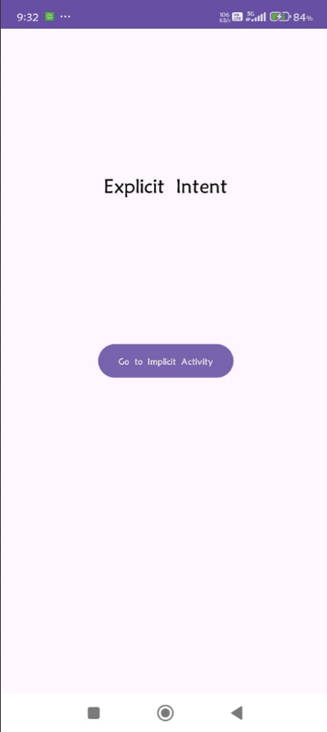 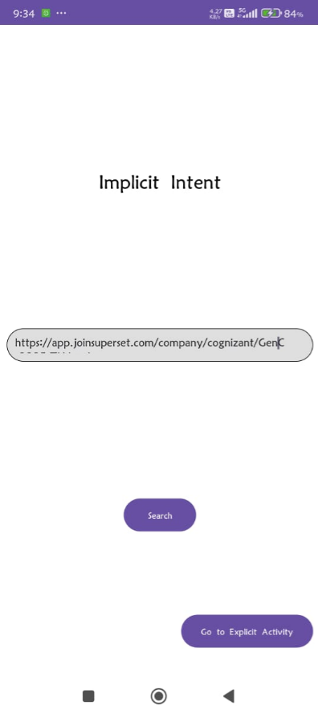

**Exp-3 (two fragments)**

**MainActivity.java**

package com.ad.clg.activitybyfragment;  
  
import android.os.Bundle;  
import androidx.appcompat.app.AppCompatActivity;  
import androidx.fragment.app.FragmentManager;  
import androidx.fragment.app.FragmentTransaction;  
  
import com.ad.clg.R;  
  
public class MainActivity extends AppCompatActivity {  
 @Override  
 protected void onCreate(Bundle savedInstanceState) {  
 super.onCreate(savedInstanceState);  
 setContentView(R.layout.*activity_main*);  
  
 // Add fragments dynamically  
 FragmentManager fragmentManager = getSupportFragmentManager();  
 FragmentTransaction fragmentTransaction = fragmentManager.beginTransaction();  
  
 fragmentTransaction.replace(R.id.*fragment1*, new Fragment1());  
 fragmentTransaction.replace(R.id.*fragment2*, new Fragment2());  
 fragmentTransaction.replace(R.id.*fragment3*, new Fragment3());  
  
 fragmentTransaction.commit();  
 }  
}

**Fragment1.java**

package com.ad.clg.activitybyfragment;  
  
import android.annotation.SuppressLint;  
import android.os.Bundle;  
import android.view.LayoutInflater;  
import android.view.View;  
import android.view.ViewGroup;  
import android.widget.Button;  
import android.widget.TextView;  
import android.widget.Toast;  
  
import androidx.fragment.app.Fragment;  
  
import com.ad.clg.R;  
  
public class Fragment1 extends Fragment {  
  
 private TextView textView;  
  
 @Override  
 public View onCreateView(LayoutInflater inflater, ViewGroup container,  
 Bundle savedInstanceState) {  
 View frag2_view = inflater.inflate(R.layout.*fragment_1*, container, false);  
 Button button = frag2_view.findViewById(R.id.*button*);  
 textView = frag2_view.findViewById(R.id.*textView*);  
  
  
 button.setOnClickListener(new View.OnClickListener() {  
 @SuppressLint("SetTextI18n")  
 @Override  
 public void onClick(View view) {  
 // Get Fragment2 instance from FragmentManager  
 Fragment2 fragment2 = (Fragment2) getParentFragmentManager().findFragmentById(R.id.*fragment2*);  
  
 if (fragment2 != null) {  
 // Update text in Fragment2's TextView  
 fragment2.updateText("Press Below button to change text of Fragment-3");  
 } else {  
 Toast.*makeText*(getActivity(), "Fragment 3 is not available", Toast.*LENGTH_SHORT*).show();  
 }  
 }  
 });  
  
  
  
 return frag2_view;  
 }  
  
 // Method to update text in Fragment2  
 public void updateText(String newText) {  
 if (textView != null) {  
 textView.setText(newText);  
 }  
 }  
}

**Fragment2.java**

package com.ad.clg.activitybyfragment;  
  
import android.annotation.SuppressLint;  
import android.os.Bundle;  
import android.view.LayoutInflater;  
import android.view.View;  
import android.view.ViewGroup;  
import android.widget.Button;  
import android.widget.TextView;  
import android.widget.Toast;  
  
import androidx.fragment.app.Fragment;  
  
import com.ad.clg.R;  
  
public class Fragment2 extends Fragment {  
  
 private TextView textView;  
  
 @Override  
 public View onCreateView(LayoutInflater inflater, ViewGroup container,  
 Bundle savedInstanceState) {  
 View frag2_view = inflater.inflate(R.layout.*fragment_2*, container, false);  
 Button button = frag2_view.findViewById(R.id.*button*);  
 textView = frag2_view.findViewById(R.id.*textView*);  
  
 button.setOnClickListener(new View.OnClickListener() {  
 @SuppressLint("SetTextI18n")  
 @Override  
 public void onClick(View view) {  
 // Get Fragment2 instance from FragmentManager  
 Fragment3 fragment3 = (Fragment3) getParentFragmentManager().findFragmentById(R.id.*fragment3*);  
  
 if (fragment3 != null) {  
 // Update text in Fragment2's TextView  
 fragment3.updateText("Press Below button to change text of Fragment-1");  
 } else {  
 Toast.*makeText*(getActivity(), "Fragment 3 is not available", Toast.*LENGTH_SHORT*).show();  
 }  
 }  
 });  
  
  
  
 return frag2_view;  
 }  
  
 // Method to update text in Fragment2  
 public void updateText(String newText) {  
 if (textView != null) {  
 textView.setText(newText);  
 }  
 }  
}

**Fragment3.java**

package com.ad.clg.activitybyfragment;  
  
import android.annotation.SuppressLint;  
import android.os.Bundle;  
import android.view.LayoutInflater;  
import android.view.View;  
import android.view.ViewGroup;  
import android.widget.Button;  
import android.widget.TextView;  
import android.widget.Toast;  
  
import androidx.fragment.app.Fragment;  
  
import com.ad.clg.R;  
  
public class Fragment3 extends Fragment {  
  
 private TextView textView;  
  
 @Override  
 public View onCreateView(LayoutInflater inflater, ViewGroup container,  
 Bundle savedInstanceState) {  
 View frag2_view = inflater.inflate(R.layout.*fragment_3*, container, false);  
 Button button = frag2_view.findViewById(R.id.*button*);  
 textView = frag2_view.findViewById(R.id.*textView*);  
  
 button.setOnClickListener(new View.OnClickListener() {  
 @SuppressLint("SetTextI18n")  
 @Override  
 public void onClick(View view) {  
 // Get Fragment2 instance from FragmentManager  
 Fragment1 fragment1 = (Fragment1) getParentFragmentManager().findFragmentById(R.id.*fragment3*);  
  
 if (fragment1 != null) {  
 // Update text in Fragment2's TextView  
 fragment1.updateText("Press Below button to change text of Fragment-2");  
 } else {  
 Toast.*makeText*(getActivity(), "Fragment 3 is not available", Toast.*LENGTH_SHORT*).show();  
 }  
 }  
 });  
  
  
  
 return frag2_view;  
 }  
  
 // Method to update text in Fragment2  
 public void updateText(String newText) {  
 if (textView != null) {  
 textView.setText(newText);  
 }  
 }  
}

**main_activity.xml**

<?xml version="1.0" encoding="utf-8"?>  
<androidx.constraintlayout.widget.ConstraintLayout xmlns:android="http://schemas.android.com/apk/res/android"  
 xmlns:app="http://schemas.android.com/apk/res-auto"  
 xmlns:tools="http://schemas.android.com/tools"  
 android:layout_width="fill_parent"  
 android:layout_height="fill_parent"  
 tools:context="com.ad.clg.activitybyfragment.MainActivity">  
  
 <fragment  
 android:id="@+id/fragment1"  
 android:name="com.ad.clg.activitybyfragment.Fragment1"  
 android:layout_width="196dp"  
 android:layout_height="246dp"  
 android:layout_weight="1"  
 app:layout_constraintBottom_toTopOf="@+id/fragment3"  
 app:layout_constraintEnd_toStartOf="@+id/fragment2"  
 app:layout_constraintHorizontal_bias="0.5"  
 app:layout_constraintStart_toStartOf="parent"  
 app:layout_constraintTop_toTopOf="parent"  
 app:layout_constraintVertical_bias="0.5" />  
  
 <fragment  
 android:id="@+id/fragment2"  
 android:name="com.ad.clg.activitybyfragment.Fragment2"  
 android:layout_width="0px"  
 android:layout_height="246dp"  
 android:layout_weight="1"  
 app:layout_constraintBottom_toTopOf="@+id/fragment3"  
 app:layout_constraintEnd_toEndOf="parent"  
 app:layout_constraintHorizontal_bias="0.5"  
 app:layout_constraintStart_toEndOf="@+id/fragment1"  
 app:layout_constraintTop_toTopOf="parent"  
 app:layout_constraintVertical_bias="0.5" />  
  
 <fragment  
 android:id="@+id/fragment3"  
 android:name="com.ad.clg.activitybyfragment.Fragment3"  
 android:layout_width="0px"  
 android:layout_height="0dp"  
 android:layout_weight="1"  
 app:layout_constraintBottom_toBottomOf="parent"  
 app:layout_constraintEnd_toEndOf="parent"  
 app:layout_constraintHorizontal_bias="0.5"  
 app:layout_constraintStart_toStartOf="parent"  
 app:layout_constraintTop_toBottomOf="@+id/fragment1"  
 app:layout_constraintVertical_bias="0.5" />  
  
</androidx.constraintlayout.widget.ConstraintLayout>

**Fragment_1.xml**

<androidx.constraintlayout.widget.ConstraintLayout xmlns:android="http://schemas.android.com/apk/res/android"  
 xmlns:app="http://schemas.android.com/apk/res-auto"  
 xmlns:tools="http://schemas.android.com/tools"  
 android:id="@+id/frag3"  
 android:layout_width="match_parent"  
 android:layout_height="match_parent"  
 android:background="#F5F5DC"  
 tools:context="com.ad.clg.activitybyfragment.Fragment1">  
  
 <TextView  
 android:id="@+id/textView"  
 android:layout_width="wrap_content"  
 android:layout_height="wrap_content"  
 android:fontFamily="sans-serif"  
 android:gravity="center"  
 android:text="Press Below button to change text of Fragment-2"  
 android:textSize="20dp"  
 android:textStyle="bold"  
 app:layout_constraintBottom_toTopOf="@+id/button"  
 app:layout_constraintEnd_toEndOf="parent"  
 app:layout_constraintHorizontal_bias="0.5"  
 app:layout_constraintStart_toStartOf="parent"  
 app:layout_constraintTop_toTopOf="parent"  
 app:layout_constraintVertical_bias="0.5" />  
  
 <Button  
 android:id="@+id/button"  
 android:layout_width="wrap_content"  
 android:layout_height="wrap_content"  
 android:text="Frag1"  
 app:layout_constraintBottom_toBottomOf="parent"  
 app:layout_constraintEnd_toEndOf="parent"  
 app:layout_constraintHorizontal_bias="0.5"  
 app:layout_constraintStart_toStartOf="parent"  
 app:layout_constraintTop_toBottomOf="@+id/textView"  
 app:layout_constraintVertical_bias="0.5" />  
  
</androidx.constraintlayout.widget.ConstraintLayout>

**fragment_2.xml**

<androidx.constraintlayout.widget.ConstraintLayout xmlns:android="http://schemas.android.com/apk/res/android"  
 xmlns:app="http://schemas.android.com/apk/res-auto"  
 android:id="@+id/frag2"  
 xmlns:tools="http://schemas.android.com/tools"  
 android:layout_width="match_parent"  
 android:layout_height="match_parent"  
 android:background="#E6E685"  
 tools:context="com.ad.clg.activitybyfragment.Fragment1">  
  
 <TextView  
 android:id="@+id/textView"  
 android:layout_width="wrap_content"  
 android:layout_height="wrap_content"  
 android:fontFamily="sans-serif"  
 android:gravity="center"  
 android:text="Default"  
 android:textSize="20dp"  
 android:textStyle="bold"  
 app:layout_constraintBottom_toTopOf="@+id/button"  
 app:layout_constraintEnd_toEndOf="parent"  
 app:layout_constraintHorizontal_bias="0.5"  
 app:layout_constraintStart_toStartOf="parent"  
 app:layout_constraintTop_toTopOf="parent"  
 app:layout_constraintVertical_bias="0.5" />  
  
 <Button  
 android:id="@+id/button"  
 android:layout_width="wrap_content"  
 android:layout_height="wrap_content"  
 android:text="Frag2"  
 app:layout_constraintBottom_toBottomOf="parent"  
 app:layout_constraintEnd_toEndOf="parent"  
 app:layout_constraintHorizontal_bias="0.5"  
 app:layout_constraintStart_toStartOf="parent"  
 app:layout_constraintTop_toBottomOf="@+id/textView"  
 app:layout_constraintVertical_bias="0.5" />  
  
</androidx.constraintlayout.widget.ConstraintLayout>

**fragment_3.xml**

<androidx.constraintlayout.widget.ConstraintLayout xmlns:android="http://schemas.android.com/apk/res/android"  
 xmlns:app="http://schemas.android.com/apk/res-auto"  
 xmlns:tools="http://schemas.android.com/tools"  
 android:layout_width="match_parent"  
 android:id="@+id/frag3"  
 android:layout_height="match_parent"  
 android:background="#90CAF9"  
 tools:context="com.ad.clg.activitybyfragment.Fragment1">  
  
 <TextView  
 android:id="@+id/textView"  
 android:layout_width="wrap_content"  
 android:layout_height="wrap_content"  
 android:fontFamily="sans-serif"  
 android:gravity="center"  
 android:text="Default"  
 android:textSize="20dp"  
 android:textStyle="bold"  
 app:layout_constraintBottom_toTopOf="@+id/button"  
 app:layout_constraintEnd_toEndOf="parent"  
 app:layout_constraintHorizontal_bias="0.5"  
 app:layout_constraintStart_toStartOf="parent"  
 app:layout_constraintTop_toTopOf="parent"  
 app:layout_constraintVertical_bias="0.5" />  
  
 <Button  
 android:id="@+id/button"  
 android:layout_width="wrap_content"  
 android:layout_height="wrap_content"  
 android:text="Fragment 3"  
 app:layout_constraintBottom_toBottomOf="parent"  
 app:layout_constraintEnd_toEndOf="parent"  
 app:layout_constraintHorizontal_bias="0.5"  
 app:layout_constraintStart_toStartOf="parent"  
 app:layout_constraintTop_toBottomOf="@+id/textView"  
 app:layout_constraintVertical_bias="0.5" />  
  
</androidx.constraintlayout.widget.ConstraintLayout>

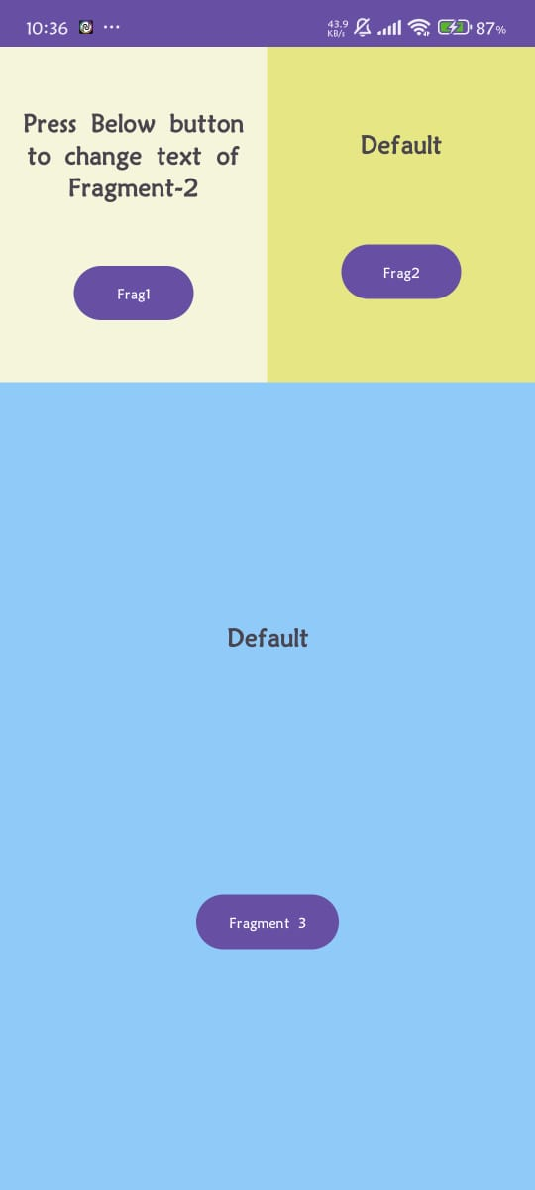

**Exp-4 (home page using grid layout)**

* **MainActivity.java**

package com.ad.homepageusinggridlayout;  
  
import android.os.Bundle;  
import android.app.Activity;  
import android.view.Menu;  
import android.widget.GridView;  
import android.os.Bundle;  
import android.app.Activity;  
import android.view.Menu;  
import android.widget.GridView;  
  
  
public class MainActivity extends Activity {  
 @Override  
 protected void onCreate(Bundle savedInstanceState) {  
 super.onCreate(savedInstanceState);  
 setContentView(R.layout.*activity_main*);  
 GridView gridview = (GridView) findViewById(R.id.*gridview*);  
 gridview.setAdapter(new ImageAdapter(this));  
 }  
}

* **ImageAdapter.java**

package com.ad.homepageusinggridlayout;  
  
import android.content.Context;  
import android.view.View;  
import android.view.ViewGroup;  
import android.widget.BaseAdapter;  
import android.widget.GridView;  
import android.widget.ImageView;  
public class ImageAdapter extends BaseAdapter {  
 private Context mContext;  
 // Constructor  
 public ImageAdapter(Context c) {  
 mContext = c;  
 }  
 public int getCount() {  
 return mThumbIds.length;  
 }  
 public Object getItem(int position) {  
 return null;  
 }  
 public long getItemId(int position) {  
 return 0;  
 }  
 // create a new ImageView for each item referenced by the Adapter  
 public View getView(int position, View convertView, ViewGroup parent) {  
 ImageView imageView;  
 if (convertView == null) {  
 imageView = new ImageView(mContext);  
 imageView.setLayoutParams(new GridView.LayoutParams(500, 500));  
 imageView.setScaleType(ImageView.ScaleType.*CENTER_CROP*);  
 imageView.setPadding(100, 50, 50, 50);  
 }  
 else  
 {  
 imageView = (ImageView) convertView;  
 }  
 imageView.setImageResource(mThumbIds[position]);  
 return imageView;  
 }  
 // Keep all Images in array  
 public Integer[] mThumbIds = {  
 R.drawable.*ic_launcher_background*, R.drawable.*ic_launcher_foreground*,  
 R.drawable.*apps*, R.drawable.*whatsapp*,  
 R.drawable.*caps*, R.drawable.*camera*,  
 R.drawable.*calc*, R.drawable.*capss*,  
 R.drawable.*loca*, R.drawable.*location*,  
 R.drawable.*baseline_location_on_24*, R.drawable.*voice*,  
 R.drawable.*voiceass*,  
 // adding all the images  
 R.drawable.*ic_launcher_background*, R.drawable.*ic_launcher_foreground*,  
 R.drawable.*apps*, R.drawable.*whatsapp*,  
 R.drawable.*caps*, R.drawable.*camera*,  
 R.drawable.*calc*, R.drawable.*capss*,  
 R.drawable.*loca*, R.drawable.*location*,  
 R.drawable.*baseline_location_on_24*, R.drawable.*voice*,  
 R.drawable.*voiceass*,  
 R.drawable.*ic_launcher_background*, R.drawable.*ic_launcher_foreground*,  
  
 };  
}

* **activity_main.xml**

<?xml version="1.0" encoding="utf-8"?>  
<androidx.constraintlayout.widget.ConstraintLayout xmlns:android="http://schemas.android.com/apk/res/android"  
 xmlns:app="http://schemas.android.com/apk/res-auto"  
 xmlns:tools="http://schemas.android.com/tools"  
 android:layout_width="match_parent"  
 android:layout_height="match_parent"  
 tools:context=".MainActivity">  
  
 <GridView  
 android:id="@+id/gridview"  
 android:layout_width="match_parent"  
 android:layout_height="match_parent"  
 android:horizontalSpacing="6dp"  
 android:numColumns="2"  
 android:verticalSpacing="6dp" />  
</androidx.constraintlayout.widget.ConstraintLayout>

* **Output**

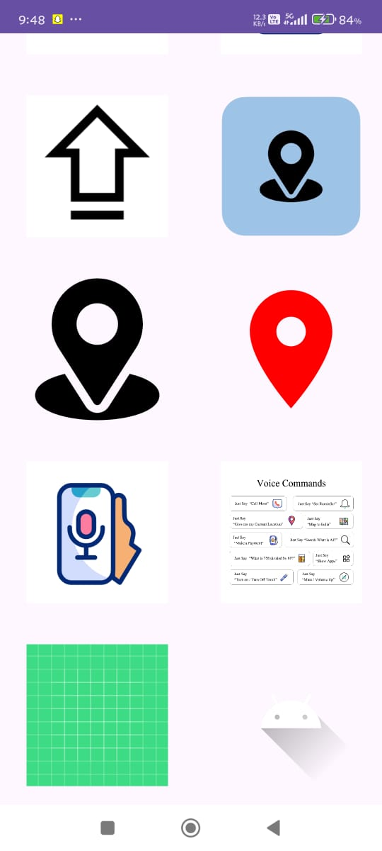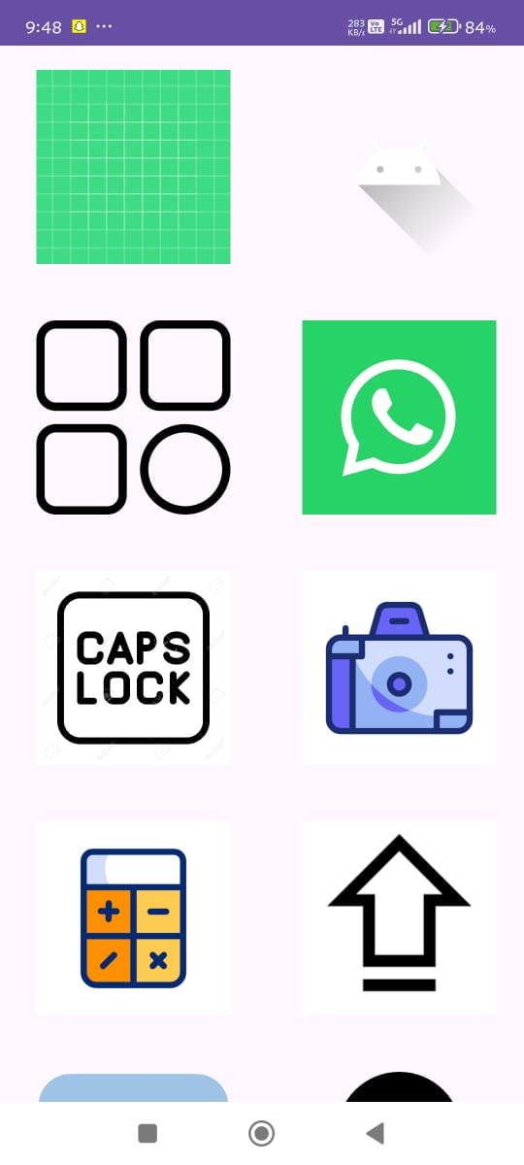

**Exp-5 (Recycle View)**

* **MainActivity.java**

package com.ad.exp9;  
import android.content.ClipData;  
import android.os.Bundle;  
import androidx.appcompat.app.AppCompatActivity;  
import androidx.recyclerview.widget.LinearLayoutManager;  
import androidx.recyclerview.widget.RecyclerView;  
import java.util.ArrayList;  
import java.util.List;  
  
public class MainActivity extends AppCompatActivity {  
  
 private RecyclerView recyclerView;  
 private ItemAdapter adapter;  
 private List<com.example.recyclerapp.Item> itemList;  
  
 @Override  
 protected void onCreate(Bundle savedInstanceState) {  
 super.onCreate(savedInstanceState);  
 setContentView(R.layout.*activity_main*);  
  
 recyclerView = findViewById(R.id.*recyclerView*);  
 recyclerView.setLayoutManager(new LinearLayoutManager(this));  
  
 // Sample data  
 itemList = new ArrayList<>();  
 itemList.add(new com.example.recyclerapp.Item("Arijit Singh"));  
 itemList.add(new com.example.recyclerapp.Item("Lata Mangeshkar"));  
 itemList.add(new com.example.recyclerapp.Item("Shreya Ghoshal"));  
 itemList.add(new com.example.recyclerapp.Item("KK"));  
 itemList.add(new com.example.recyclerapp.Item("Sonu Nigam"));  
 itemList.add(new com.example.recyclerapp.Item("Mohit Chauhan"));  
 itemList.add(new com.example.recyclerapp.Item("Armaan Malik"));  
 itemList.add(new com.example.recyclerapp.Item("Neha Kakkar"));  
  
 adapter = new ItemAdapter(itemList);  
 recyclerView.setAdapter(adapter);  
 }  
}

* **Item.java**

package com.ad.exp9;  
public class Item {  
 private String title;  
 public Item(String title) {  
 this.title = title;  
 }  
 public String getTitle() {  
 return title;  
 }  
}

* **ItemAdapter.java**

package com.ad.exp9;  
import android.content.ClipData;  
import android.view.LayoutInflater;  
import android.view.View;  
import android.view.ViewGroup;  
import android.widget.TextView;  
import androidx.recyclerview.widget.RecyclerView;  
import java.util.List;  
  
public class ItemAdapter extends RecyclerView.Adapter<ItemAdapter.ViewHolder> {  
  
 private List<com.example.recyclerapp.Item> itemList;  
  
 public ItemAdapter(List<com.example.recyclerapp.Item> itemList) {  
 this.itemList = itemList;  
 }  
  
 public static class ViewHolder extends RecyclerView.ViewHolder {  
 public TextView textViewTitle;  
  
 public ViewHolder(View itemView) {  
 super(itemView);  
 textViewTitle = itemView.findViewById(R.id.*textViewTitle*);  
 }  
 }  
  
 @Override  
 public ItemAdapter.ViewHolder onCreateViewHolder(ViewGroup parent, int viewType) {  
 View v = LayoutInflater.*from*(parent.getContext()).inflate(R.layout.*item_layout*, parent, false);  
 return new ViewHolder(v);  
 }  
  
 @Override  
 public void onBindViewHolder(ItemAdapter.ViewHolder holder, int position) {  
 com.example.recyclerapp.Item item = itemList.get(position);  
 holder.textViewTitle.setText(item.getTitle());  
 }  
  
 @Override  
 public int getItemCount() {  
 return itemList.size();  
 }  
}

* Item_layput.xml

<?xml version="1.0" encoding="utf-8"?>  
<androidx.cardview.widget.CardView xmlns:android="http://schemas.android.com/apk/res/android"  
 android:layout_width="match_parent"  
 android:layout_height="wrap_content"  
 android:layout_margin="8dp"  
 android:elevation="4dp"  
 android:padding="16dp">  
  
 <TextView  
 android:id="@+id/textViewTitle"  
 android:layout_width="wrap_content"  
 android:layout_height="wrap_content"  
 android:text="Sample Item"  
 android:textSize="18sp"  
 android:textColor="#000" />  
</androidx.cardview.widget.CardView>

* **output**

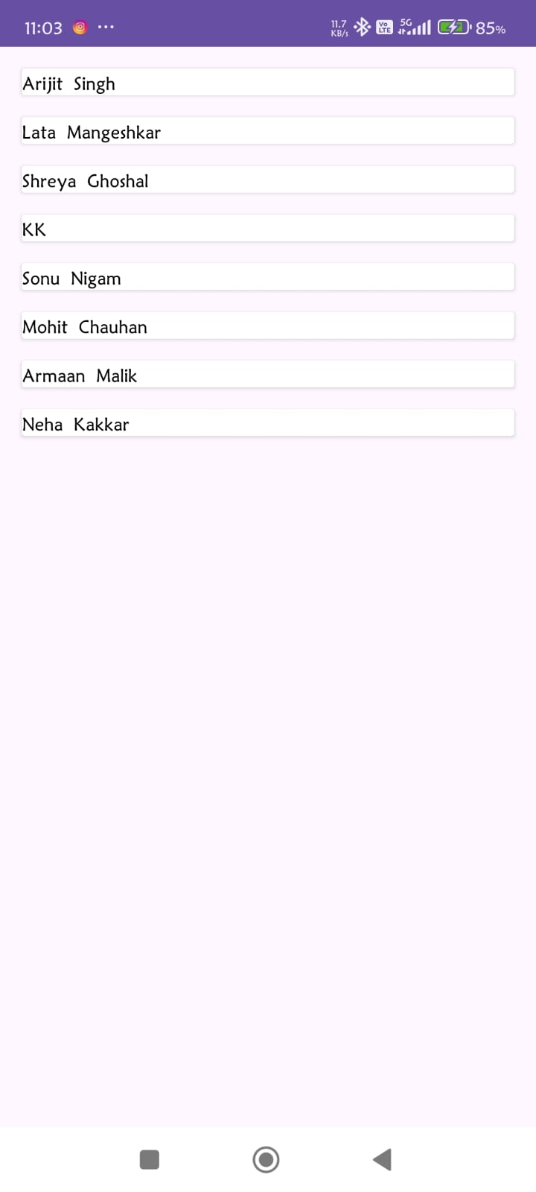

**Exp-6 (Webview)**

* **MainActivity.java**

package com.example.webviewapp;

import android.os.Bundle;

import android.webkit.WebSettings;

import android.webkit.WebView;

import android.webkit.WebViewClient;

import androidx.appcompat.app.AppCompatActivity;

public class MainActivity extends AppCompatActivity {

WebView myWebView;

@Override

protected void onCreate(Bundle savedInstanceState) {

super.onCreate(savedInstanceState);

setContentView(R.layout.activity_main);

myWebView = findViewById(R.id.myWebView);

// Enable JavaScript

WebSettings webSettings = myWebView.getSettings();

webSettings.setJavaScriptEnabled(true);

// Load your website

myWebView.loadUrl("https://www.example.com");

// Open links in the same WebView

myWebView.setWebViewClient(new WebViewClient());

}

@Override

public void onBackPressed() {

if (myWebView.canGoBack()) {

myWebView.goBack();

} else {

super.onBackPressed();

}

}

}

* **Activity_main.xml**

<?xml version="1.0" encoding="utf-8"?>

<RelativeLayout xmlns:android="http://schemas.android.com/apk/res/android"

android:layout_width="match_parent"

android:layout_height="match_parent">

<WebView

android:id="@+id/myWebView"

android:layout_width="match_parent"

android:layout_height="match_parent" />

</RelativeLayout>

* **Output**

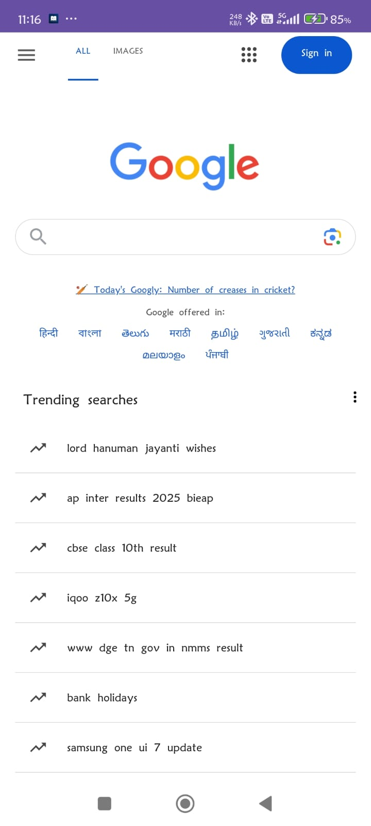

**Exp-8 (Image slider)**

* **MainActivity.java**

package com.ad.homepageusinggridlayout;  
  
import android.os.Bundle;  
import android.app.Activity;  
import android.view.Menu;  
import android.widget.GridView;  
import android.os.Bundle;  
import android.app.Activity;  
import android.view.Menu;  
import android.widget.GridView;  
  
  
public class MainActivity extends Activity {  
 @Override  
 protected void onCreate(Bundle savedInstanceState) {  
 super.onCreate(savedInstanceState);  
 setContentView(R.layout.*activity_main*);  
 GridView gridview = (GridView) findViewById(R.id.*gridview*);  
 gridview.setAdapter(new ImageAdapter(this));  
 }  
}

* **ImageAdapter.java**

package com.ad.homepageusinggridlayout;  
  
import android.content.Context;  
import android.view.View;  
import android.view.ViewGroup;  
import android.widget.BaseAdapter;  
import android.widget.GridView;  
import android.widget.ImageView;  
public class ImageAdapter extends BaseAdapter {  
 private Context mContext;  
 // Constructor  
 public ImageAdapter(Context c) {  
 mContext = c;  
 }  
 public int getCount() {  
 return mThumbIds.length;  
 }  
 public Object getItem(int position) {  
 return null;  
 }  
 public long getItemId(int position) {  
 return 0;  
 }  
 // create a new ImageView for each item referenced by the Adapter  
 public View getView(int position, View convertView, ViewGroup parent) {  
 ImageView imageView;  
 if (convertView == null) {  
 imageView = new ImageView(mContext);  
 imageView.setLayoutParams(new GridView.LayoutParams(500, 500));  
 imageView.setScaleType(ImageView.ScaleType.*CENTER_CROP*);  
 imageView.setPadding(100, 50, 50, 50);  
 }  
 else  
 {  
 imageView = (ImageView) convertView;  
 }  
 imageView.setImageResource(mThumbIds[position]);  
 return imageView;  
 }  
 // Keep all Images in array  
 public Integer[] mThumbIds = {  
 R.drawable.*ic_launcher_background*, R.drawable.*ic_launcher_foreground*,  
 R.drawable.*apps*, R.drawable.*whatsapp*,  
 R.drawable.*caps*, R.drawable.*camera*,  
 R.drawable.*calc*, R.drawable.*capss*,  
 R.drawable.*loca*, R.drawable.*location*,  
 R.drawable.*baseline_location_on_24*, R.drawable.*voice*,  
 R.drawable.*voiceass*,  
 // adding all the images  
 R.drawable.*ic_launcher_background*, R.drawable.*ic_launcher_foreground*,  
 R.drawable.*apps*, R.drawable.*whatsapp*,  
 R.drawable.*caps*, R.drawable.*camera*,  
 R.drawable.*calc*, R.drawable.*capss*,  
 R.drawable.*loca*, R.drawable.*location*,  
 R.drawable.*baseline_location_on_24*, R.drawable.*voice*,  
 R.drawable.*voiceass*,  
 R.drawable.*ic_launcher_background*, R.drawable.*ic_launcher_foreground*,  
  
 };  
}

* **activity_main.xml**

<?xml version="1.0" encoding="utf-8"?>  
<androidx.constraintlayout.widget.ConstraintLayout xmlns:android="http://schemas.android.com/apk/res/android"  
 xmlns:app="http://schemas.android.com/apk/res-auto"  
 xmlns:tools="http://schemas.android.com/tools"  
 android:layout_width="match_parent"  
 android:layout_height="match_parent"  
 tools:context=".MainActivity">  
  
 <GridView  
 android:id="@+id/gridview"  
 android:layout_width="match_parent"  
 android:layout_height="match_parent"  
 android:horizontalSpacing="6dp"  
 android:numColumns="2"  
 android:verticalSpacing="6dp" />  
</androidx.constraintlayout.widget.ConstraintLayout>

* **Output**



**Exp-7 (fragments)**

**MainActivity.java**

package com.ad.clg.activitybyfragment;  
  
import android.os.Bundle;  
import androidx.appcompat.app.AppCompatActivity;  
import androidx.fragment.app.FragmentManager;  
import androidx.fragment.app.FragmentTransaction;  
  
import com.ad.clg.R;  
  
public class MainActivity extends AppCompatActivity {  
 @Override  
 protected void onCreate(Bundle savedInstanceState) {  
 super.onCreate(savedInstanceState);  
 setContentView(R.layout.*activity_main*);  
  
 // Add fragments dynamically  
 FragmentManager fragmentManager = getSupportFragmentManager();  
 FragmentTransaction fragmentTransaction = fragmentManager.beginTransaction();  
  
 fragmentTransaction.replace(R.id.*fragment1*, new Fragment1());  
 fragmentTransaction.replace(R.id.*fragment2*, new Fragment2());  
 fragmentTransaction.replace(R.id.*fragment3*, new Fragment3());  
  
 fragmentTransaction.commit();  
 }  
}

**Fragment1.java**

package com.ad.clg.activitybyfragment;  
  
import android.annotation.SuppressLint;  
import android.os.Bundle;  
import android.view.LayoutInflater;  
import android.view.View;  
import android.view.ViewGroup;  
import android.widget.Button;  
import android.widget.TextView;  
import android.widget.Toast;  
  
import androidx.fragment.app.Fragment;  
  
import com.ad.clg.R;  
  
public class Fragment1 extends Fragment {  
  
 private TextView textView;  
  
 @Override  
 public View onCreateView(LayoutInflater inflater, ViewGroup container,  
 Bundle savedInstanceState) {  
 View frag2_view = inflater.inflate(R.layout.*fragment_1*, container, false);  
 Button button = frag2_view.findViewById(R.id.*button*);  
 textView = frag2_view.findViewById(R.id.*textView*);  
  
  
 button.setOnClickListener(new View.OnClickListener() {  
 @SuppressLint("SetTextI18n")  
 @Override  
 public void onClick(View view) {  
 // Get Fragment2 instance from FragmentManager  
 Fragment2 fragment2 = (Fragment2) getParentFragmentManager().findFragmentById(R.id.*fragment2*);  
  
 if (fragment2 != null) {  
 // Update text in Fragment2's TextView  
 fragment2.updateText("Press Below button to change text of Fragment-3");  
 } else {  
 Toast.*makeText*(getActivity(), "Fragment 3 is not available", Toast.*LENGTH_SHORT*).show();  
 }  
 }  
 });  
  
  
  
 return frag2_view;  
 }  
  
 // Method to update text in Fragment2  
 public void updateText(String newText) {  
 if (textView != null) {  
 textView.setText(newText);  
 }  
 }  
}

**Fragment2.java**

package com.ad.clg.activitybyfragment;  
  
import android.annotation.SuppressLint;  
import android.os.Bundle;  
import android.view.LayoutInflater;  
import android.view.View;  
import android.view.ViewGroup;  
import android.widget.Button;  
import android.widget.TextView;  
import android.widget.Toast;  
  
import androidx.fragment.app.Fragment;  
  
import com.ad.clg.R;  
  
public class Fragment2 extends Fragment {  
  
 private TextView textView;  
  
 @Override  
 public View onCreateView(LayoutInflater inflater, ViewGroup container,  
 Bundle savedInstanceState) {  
 View frag2_view = inflater.inflate(R.layout.*fragment_2*, container, false);  
 Button button = frag2_view.findViewById(R.id.*button*);  
 textView = frag2_view.findViewById(R.id.*textView*);  
  
 button.setOnClickListener(new View.OnClickListener() {  
 @SuppressLint("SetTextI18n")  
 @Override  
 public void onClick(View view) {  
 // Get Fragment2 instance from FragmentManager  
 Fragment3 fragment3 = (Fragment3) getParentFragmentManager().findFragmentById(R.id.*fragment3*);  
  
 if (fragment3 != null) {  
 // Update text in Fragment2's TextView  
 fragment3.updateText("Press Below button to change text of Fragment-1");  
 } else {  
 Toast.*makeText*(getActivity(), "Fragment 3 is not available", Toast.*LENGTH_SHORT*).show();  
 }  
 }  
 });  
  
  
  
 return frag2_view;  
 }  
  
 // Method to update text in Fragment2  
 public void updateText(String newText) {  
 if (textView != null) {  
 textView.setText(newText);  
 }  
 }  
}

**Fragment3.java**

package com.ad.clg.activitybyfragment;  
  
import android.annotation.SuppressLint;  
import android.os.Bundle;  
import android.view.LayoutInflater;  
import android.view.View;  
import android.view.ViewGroup;  
import android.widget.Button;  
import android.widget.TextView;  
import android.widget.Toast;  
  
import androidx.fragment.app.Fragment;  
  
import com.ad.clg.R;  
  
public class Fragment3 extends Fragment {  
  
 private TextView textView;  
  
 @Override  
 public View onCreateView(LayoutInflater inflater, ViewGroup container,  
 Bundle savedInstanceState) {  
 View frag2_view = inflater.inflate(R.layout.*fragment_3*, container, false);  
 Button button = frag2_view.findViewById(R.id.*button*);  
 textView = frag2_view.findViewById(R.id.*textView*);  
  
 button.setOnClickListener(new View.OnClickListener() {  
 @SuppressLint("SetTextI18n")  
 @Override  
 public void onClick(View view) {  
 // Get Fragment2 instance from FragmentManager  
 Fragment1 fragment1 = (Fragment1) getParentFragmentManager().findFragmentById(R.id.*fragment3*);  
  
 if (fragment1 != null) {  
 // Update text in Fragment2's TextView  
 fragment1.updateText("Press Below button to change text of Fragment-2");  
 } else {  
 Toast.*makeText*(getActivity(), "Fragment 3 is not available", Toast.*LENGTH_SHORT*).show();  
 }  
 }  
 });  
  
  
  
 return frag2_view;  
 }  
  
 // Method to update text in Fragment2  
 public void updateText(String newText) {  
 if (textView != null) {  
 textView.setText(newText);  
 }  
 }  
}

**main_activity.xml**

<?xml version="1.0" encoding="utf-8"?>  
<androidx.constraintlayout.widget.ConstraintLayout xmlns:android="http://schemas.android.com/apk/res/android"  
 xmlns:app="http://schemas.android.com/apk/res-auto"  
 xmlns:tools="http://schemas.android.com/tools"  
 android:layout_width="fill_parent"  
 android:layout_height="fill_parent"  
 tools:context="com.ad.clg.activitybyfragment.MainActivity">  
  
 <fragment  
 android:id="@+id/fragment1"  
 android:name="com.ad.clg.activitybyfragment.Fragment1"  
 android:layout_width="196dp"  
 android:layout_height="246dp"  
 android:layout_weight="1"  
 app:layout_constraintBottom_toTopOf="@+id/fragment3"  
 app:layout_constraintEnd_toStartOf="@+id/fragment2"  
 app:layout_constraintHorizontal_bias="0.5"  
 app:layout_constraintStart_toStartOf="parent"  
 app:layout_constraintTop_toTopOf="parent"  
 app:layout_constraintVertical_bias="0.5" />  
  
 <fragment  
 android:id="@+id/fragment2"  
 android:name="com.ad.clg.activitybyfragment.Fragment2"  
 android:layout_width="0px"  
 android:layout_height="246dp"  
 android:layout_weight="1"  
 app:layout_constraintBottom_toTopOf="@+id/fragment3"  
 app:layout_constraintEnd_toEndOf="parent"  
 app:layout_constraintHorizontal_bias="0.5"  
 app:layout_constraintStart_toEndOf="@+id/fragment1"  
 app:layout_constraintTop_toTopOf="parent"  
 app:layout_constraintVertical_bias="0.5" />  
  
 <fragment  
 android:id="@+id/fragment3"  
 android:name="com.ad.clg.activitybyfragment.Fragment3"  
 android:layout_width="0px"  
 android:layout_height="0dp"  
 android:layout_weight="1"  
 app:layout_constraintBottom_toBottomOf="parent"  
 app:layout_constraintEnd_toEndOf="parent"  
 app:layout_constraintHorizontal_bias="0.5"  
 app:layout_constraintStart_toStartOf="parent"  
 app:layout_constraintTop_toBottomOf="@+id/fragment1"  
 app:layout_constraintVertical_bias="0.5" />  
  
</androidx.constraintlayout.widget.ConstraintLayout>

**Fragment_1.xml**

<androidx.constraintlayout.widget.ConstraintLayout xmlns:android="http://schemas.android.com/apk/res/android"  
 xmlns:app="http://schemas.android.com/apk/res-auto"  
 xmlns:tools="http://schemas.android.com/tools"  
 android:id="@+id/frag3"  
 android:layout_width="match_parent"  
 android:layout_height="match_parent"  
 android:background="#F5F5DC"  
 tools:context="com.ad.clg.activitybyfragment.Fragment1">  
  
 <TextView  
 android:id="@+id/textView"  
 android:layout_width="wrap_content"  
 android:layout_height="wrap_content"  
 android:fontFamily="sans-serif"  
 android:gravity="center"  
 android:text="Press Below button to change text of Fragment-2"  
 android:textSize="20dp"  
 android:textStyle="bold"  
 app:layout_constraintBottom_toTopOf="@+id/button"  
 app:layout_constraintEnd_toEndOf="parent"  
 app:layout_constraintHorizontal_bias="0.5"  
 app:layout_constraintStart_toStartOf="parent"  
 app:layout_constraintTop_toTopOf="parent"  
 app:layout_constraintVertical_bias="0.5" />  
  
 <Button  
 android:id="@+id/button"  
 android:layout_width="wrap_content"  
 android:layout_height="wrap_content"  
 android:text="Frag1"  
 app:layout_constraintBottom_toBottomOf="parent"  
 app:layout_constraintEnd_toEndOf="parent"  
 app:layout_constraintHorizontal_bias="0.5"  
 app:layout_constraintStart_toStartOf="parent"  
 app:layout_constraintTop_toBottomOf="@+id/textView"  
 app:layout_constraintVertical_bias="0.5" />  
  
</androidx.constraintlayout.widget.ConstraintLayout>

**fragment_2.xml**

<androidx.constraintlayout.widget.ConstraintLayout xmlns:android="http://schemas.android.com/apk/res/android"  
 xmlns:app="http://schemas.android.com/apk/res-auto"  
 android:id="@+id/frag2"  
 xmlns:tools="http://schemas.android.com/tools"  
 android:layout_width="match_parent"  
 android:layout_height="match_parent"  
 android:background="#E6E685"  
 tools:context="com.ad.clg.activitybyfragment.Fragment1">  
  
 <TextView  
 android:id="@+id/textView"  
 android:layout_width="wrap_content"  
 android:layout_height="wrap_content"  
 android:fontFamily="sans-serif"  
 android:gravity="center"  
 android:text="Default"  
 android:textSize="20dp"  
 android:textStyle="bold"  
 app:layout_constraintBottom_toTopOf="@+id/button"  
 app:layout_constraintEnd_toEndOf="parent"  
 app:layout_constraintHorizontal_bias="0.5"  
 app:layout_constraintStart_toStartOf="parent"  
 app:layout_constraintTop_toTopOf="parent"  
 app:layout_constraintVertical_bias="0.5" />  
  
 <Button  
 android:id="@+id/button"  
 android:layout_width="wrap_content"  
 android:layout_height="wrap_content"  
 android:text="Frag2"  
 app:layout_constraintBottom_toBottomOf="parent"  
 app:layout_constraintEnd_toEndOf="parent"  
 app:layout_constraintHorizontal_bias="0.5"  
 app:layout_constraintStart_toStartOf="parent"  
 app:layout_constraintTop_toBottomOf="@+id/textView"  
 app:layout_constraintVertical_bias="0.5" />  
  
</androidx.constraintlayout.widget.ConstraintLayout>

**fragment_3.xml**

<androidx.constraintlayout.widget.ConstraintLayout xmlns:android="http://schemas.android.com/apk/res/android"  
 xmlns:app="http://schemas.android.com/apk/res-auto"  
 xmlns:tools="http://schemas.android.com/tools"  
 android:layout_width="match_parent"  
 android:id="@+id/frag3"  
 android:layout_height="match_parent"  
 android:background="#90CAF9"  
 tools:context="com.ad.clg.activitybyfragment.Fragment1">  
  
 <TextView  
 android:id="@+id/textView"  
 android:layout_width="wrap_content"  
 android:layout_height="wrap_content"  
 android:fontFamily="sans-serif"  
 android:gravity="center"  
 android:text="Default"  
 android:textSize="20dp"  
 android:textStyle="bold"  
 app:layout_constraintBottom_toTopOf="@+id/button"  
 app:layout_constraintEnd_toEndOf="parent"  
 app:layout_constraintHorizontal_bias="0.5"  
 app:layout_constraintStart_toStartOf="parent"  
 app:layout_constraintTop_toTopOf="parent"  
 app:layout_constraintVertical_bias="0.5" />  
  
 <Button  
 android:id="@+id/button"  
 android:layout_width="wrap_content"  
 android:layout_height="wrap_content"  
 android:text="Fragment 3"  
 app:layout_constraintBottom_toBottomOf="parent"  
 app:layout_constraintEnd_toEndOf="parent"  
 app:layout_constraintHorizontal_bias="0.5"  
 app:layout_constraintStart_toStartOf="parent"  
 app:layout_constraintTop_toBottomOf="@+id/textView"  
 app:layout_constraintVertical_bias="0.5" />  
  
</androidx.constraintlayout.widget.ConstraintLayout>



**Exp-9 (media player)**

package com.vivssecure.family;  
  
import android.annotation.SuppressLint;  
import android.media.MediaPlayer;  
import android.os.Bundle;  
import android.os.Handler;  
import android.widget.Button;  
import android.widget.SeekBar;  
import android.widget.TextView;  
  
import androidx.appcompat.app.AppCompatActivity;  
  
public class MusicPlayer extends AppCompatActivity {  
  
 MediaPlayer mediaPlayer;  
 Button playBtn, pauseBtn, stopBtn;  
 SeekBar seekBar;  
 TextView songTitle;  
  
 Handler handler = new Handler();  
 Runnable updateSeekBar;  
  
 @SuppressLint("SetTextI18n")  
 @Override  
 protected void onCreate(Bundle savedInstanceState) {  
 super.onCreate(savedInstanceState);  
 setContentView(R.layout.music_player);  
  
 playBtn = findViewById(R.id.playBtn);  
 pauseBtn = findViewById(R.id.pauseBtn);  
 stopBtn = findViewById(R.id.stopBtn);  
 seekBar = findViewById(R.id.seekBar);  
 songTitle = findViewById(R.id.songTitle);  
  
 // Set song name  
 songTitle.setText("Song: Camila Cabello - Señorita");  
  
 mediaPlayer = MediaPlayer.create(this, R.raw.song);  
 seekBar.setMax(mediaPlayer.getDuration());  
  
 // Update SeekBar periodically  
 updateSeekBar = new Runnable() {  
 @Override  
 public void run() {  
 if (mediaPlayer != null && mediaPlayer.isPlaying()) {  
 seekBar.setProgress(mediaPlayer.getCurrentPosition());  
 handler.postDelayed(this, 500);  
 }  
 }  
 };  
  
 playBtn.setOnClickListener(v -> {  
 if (!mediaPlayer.isPlaying()) {  
 mediaPlayer.start();  
 handler.post(updateSeekBar);  
 }  
 });  
  
 pauseBtn.setOnClickListener(v -> {  
 if (mediaPlayer.isPlaying()) {  
 mediaPlayer.pause();  
 }  
 });  
  
 stopBtn.setOnClickListener(v -> {  
 if (mediaPlayer != null) {  
 mediaPlayer.stop();  
 mediaPlayer.release();  
 mediaPlayer = MediaPlayer.create(this, R.raw.song);  
 seekBar.setProgress(0);  
 }  
 });  
  
 // SeekBar change by user  
 seekBar.setOnSeekBarChangeListener(new SeekBar.OnSeekBarChangeListener() {  
 boolean userTouching = false;  
  
 @Override  
 public void onProgressChanged(SeekBar seekBar, int progress, boolean fromUser) {  
 if (fromUser && mediaPlayer != null) {  
 mediaPlayer.seekTo(progress);  
 }  
 }  
  
 @Override  
 public void onStartTrackingTouch(SeekBar seekBar) {  
 userTouching = true;  
 }  
  
 @Override  
 public void onStopTrackingTouch(SeekBar seekBar) {  
 userTouching = false;  
 }  
 });  
 }  
  
 @Override  
 protected void onDestroy() {  
 handler.removeCallbacks(updateSeekBar);  
 if (mediaPlayer != null) {  
 mediaPlayer.release();  
 mediaPlayer = null;  
 }  
 super.onDestroy();  
 }  
}

* **musicplayer.xml**

<?xml version="1.0" encoding="utf-8"?>  
<LinearLayout  
 xmlns:android="http://schemas.android.com/apk/res/android"  
 android:layout_width="match_parent"  
 android:layout_height="match_parent"  
 android:gravity="center"  
 android:orientation="vertical"  
 android:padding="24dp">  
  
 <TextView  
 android:id="@+id/songTitle"  
 android:layout_width="wrap_content"  
 android:layout_height="wrap_content"  
 android:text="Song: Beautiful Melody"  
 android:textSize="18sp"  
 android:textStyle="bold"  
 android:layout_marginBottom="20dp"/>  
  
 <SeekBar  
 android:id="@+id/seekBar"  
 android:layout_width="match_parent"  
 android:layout_height="wrap_content" />  
  
 <LinearLayout  
 android:layout_width="wrap_content"  
 android:layout_height="wrap_content"  
 android:orientation="horizontal"  
 android:layout_marginTop="24dp">  
  
 <Button  
 android:id="@+id/playBtn"  
 android:layout_width="wrap_content"  
 android:layout_height="wrap_content"  
 android:text="Play" />  
  
 <Button  
 android:id="@+id/pauseBtn"  
 android:layout_width="wrap_content"  
 android:layout_height="wrap_content"  
 android:text="Pause"  
 android:layout_marginLeft="16dp" />  
  
 <Button  
 android:id="@+id/stopBtn"  
 android:layout_width="wrap_content"  
 android:layout_height="wrap_content"  
 android:text="Stop"  
 android:layout_marginLeft="16dp" />  
 </LinearLayout>  
</LinearLayout>

* **output**

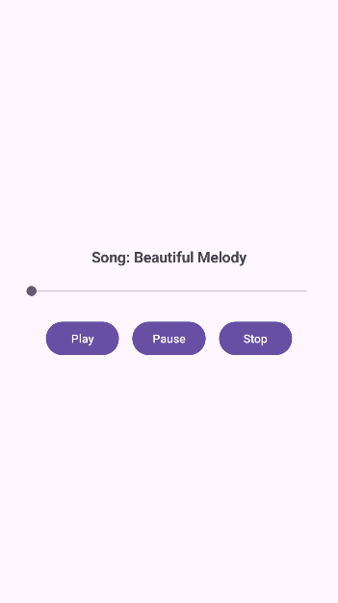

**Exp-10 (google maps)**

* **MainActivity.java**

package com.example.mapsdemo;

import android.Manifest;

import android.content.pm.PackageManager;

import android.location.Location;

import android.os.Bundle;

import androidx.annotation.NonNull;

import androidx.appcompat.app.AppCompatActivity;

import androidx.core.app.ActivityCompat;

import com.google.android.gms.location.FusedLocationProviderClient;

import com.google.android.gms.location.LocationServices;

import com.google.android.gms.maps.CameraUpdateFactory;

import com.google.android.gms.maps.GoogleMap;

import com.google.android.gms.maps.OnMapReadyCallback;

import com.google.android.gms.maps.SupportMapFragment;

import com.google.android.gms.maps.model.LatLng;

import com.google.android.gms.maps.model.MarkerOptions;

public class MapsActivity extends AppCompatActivity implements OnMapReadyCallback {

private static final int LOCATION_PERMISSION_REQUEST_CODE = 1001;

private GoogleMap mMap;

private FusedLocationProviderClient fusedLocationClient;

@Override

protected void onCreate(Bundle savedInstanceState) {

super.onCreate(savedInstanceState);

setContentView(R.layout.activity_maps);

fusedLocationClient = LocationServices.getFusedLocationProviderClient(this);

SupportMapFragment mapFragment =

(SupportMapFragment) getSupportFragmentManager().findFragmentById(R.id.map);

if (mapFragment != null) {

mapFragment.getMapAsync(this);

}

}

@Override

public void onMapReady(@NonNull GoogleMap googleMap) {

mMap = googleMap;

enableMyLocation();

}

private void enableMyLocation() {

if (ActivityCompat.checkSelfPermission(this, Manifest.permission.ACCESS_FINE_LOCATION)

!= PackageManager.PERMISSION_GRANTED) {

ActivityCompat.requestPermissions(this,

new String[]{Manifest.permission.ACCESS_FINE_LOCATION},

LOCATION_PERMISSION_REQUEST_CODE);

} else {

mMap.setMyLocationEnabled(true);

fusedLocationClient.getLastLocation()

.addOnSuccessListener(this, location -> {

if (location != null) {

LatLng current = new LatLng(location.getLatitude(), location.getLongitude());

mMap.addMarker(new MarkerOptions().position(current).title("You are here"));

mMap.moveCamera(CameraUpdateFactory.newLatLngZoom(current, 16f));

}

});

}

}

@Override

public void onRequestPermissionsResult(int requestCode,

@NonNull String[] permissions,

@NonNull int[] grantResults) {

if (requestCode == LOCATION_PERMISSION_REQUEST_CODE) {

if (grantResults.length > 0 &&

grantResults[0] == PackageManager.PERMISSION_GRANTED) {

enableMyLocation();

}

}

}

}

* **Activity_main.xml**

<?xml version="1.0" encoding="utf-8"?>

<FrameLayout xmlns:android="http://schemas.android.com/apk/res/android"

android:id="@+id/map_container"

android:layout_width="match_parent"

android:layout_height="match_parent">

<fragment

android:id="@+id/map"

android:name="com.google.android.gms.maps.SupportMapFragment"

android:layout_width="match_parent"

android:layout_height="match_parent" />

</FrameLayout>

* **output**

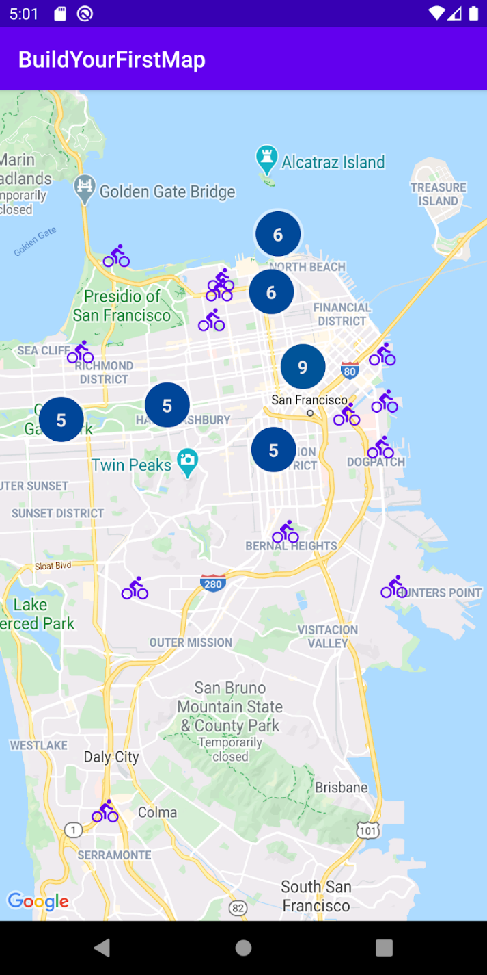

**Exp-11 (color picker)**

* **Mainactivity.java**

package com.example.colorpicker

import android.graphics.Color

import android.os.Bundle

import android.widget.SeekBar

import androidx.appcompat.app.AppCompatActivity

import com.example.colorpicker.databinding.ActivityMainBinding

class MainActivity : AppCompatActivity() {

private lateinit var binding: ActivityMainBinding

private var hsv = floatArrayOf(0f, 1f, 1f)

private var alpha = 255

override fun onCreate(savedInstanceState: Bundle?) {

super.onCreate(savedInstanceState)

binding = ActivityMainBinding.inflate(layoutInflater)

setContentView(binding.root)

val colorWheel = binding.colorWheel

val preview = binding.previewColor

colorWheel.setOnColorChangeListener { hue, saturation ->

hsv[0] = hue

hsv[1] = saturation

updateColor()

}

binding.alphaSeekBar.setOnSeekBarChangeListener(seekListener { value ->

alpha = value

updateColor()

})

binding.valueSeekBar.setOnSeekBarChangeListener(seekListener { value ->

hsv[2] = value / 100f

updateColor()

})

}

private fun updateColor() {

val color = Color.HSVToColor(alpha, hsv)

binding.previewColor.setBackgroundColor(color)

}

private fun seekListener(onProgressChanged: (progress: Int) -> Unit) =

object : SeekBar.OnSeekBarChangeListener {

override fun onProgressChanged(sb: SeekBar?, progress: Int, fromUser: Boolean) {

onProgressChanged(progress)

}

override fun onStartTrackingTouch(sb: SeekBar?) {}

override fun onStopTrackingTouch(sb: SeekBar?) {}

}

}

* Activity.xml

<?xml version="1.0" encoding="utf-8"?>

<RelativeLayout xmlns:android="http://schemas.android.com/apk/res/android"

android:id="@+id/rootLayout"

android:layout_width="match_parent"

android:layout_height="match_parent"

android:padding="20dp">

<com.example.colorpicker.ColorWheelView

android:id="@+id/colorWheel"

android:layout_width="300dp"

android:layout_height="300dp"

android:layout_centerHorizontal="true"

android:layout_marginTop="40dp" />

<SeekBar

android:id="@+id/alphaSeekBar"

android:layout_below="@id/colorWheel"

android:layout_marginTop="20dp"

android:layout_width="match_parent"

android:layout_height="wrap_content"

android:max="255"/>

<SeekBar

android:id="@+id/valueSeekBar"

android:layout_below="@id/alphaSeekBar"

android:layout_marginTop="10dp"

android:layout_width="match_parent"

android:layout_height="wrap_content"

android:max="100"/>

<View

android:id="@+id/previewColor"

android:layout_width="match_parent"

android:layout_height="100dp"

android:layout_below="@id/valueSeekBar"

android:layout_marginTop="20dp"

android:background="#FFFFFF"/>

</RelativeLayout>

* **Output**

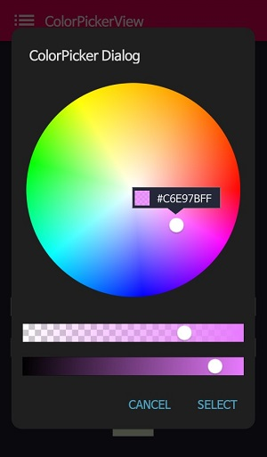

**Exp-12 (calculator)**

* **Mainactivity.java**

package com.vivssecure.family;  
  
import android.os.Bundle;  
import android.view.View;  
import android.widget.*;  
import androidx.appcompat.app.AppCompatActivity;  
  
public class MusicPlayer extends AppCompatActivity {  
  
 EditText etNum1, etNum2;  
 Button btnAdd, btnSub, btnMul, btnDiv;  
 TextView tvResult;  
  
 @Override  
 protected void onCreate(Bundle savedInstanceState) {  
 super.onCreate(savedInstanceState);  
 setContentView(R.layout.*music_player*);  
  
 etNum1 = findViewById(R.id.*etNum1*);  
 etNum2 = findViewById(R.id.*etNum2*);  
 btnAdd = findViewById(R.id.*btnAdd*);  
 btnSub = findViewById(R.id.*btnSub*);  
 btnMul = findViewById(R.id.*btnMul*);  
 btnDiv = findViewById(R.id.*btnDiv*);  
 tvResult = findViewById(R.id.*tvResult*);  
  
 btnAdd.setOnClickListener(v -> calculate('+'));  
 btnSub.setOnClickListener(v -> calculate('-'));  
 btnMul.setOnClickListener(v -> calculate('*'));  
 btnDiv.setOnClickListener(v -> calculate('/'));  
 }  
  
 private void calculate(char operator) {  
 String input1 = etNum1.getText().toString();  
 String input2 = etNum2.getText().toString();  
  
 if (input1.isEmpty() || input2.isEmpty()) {  
 Toast.*makeText*(this, "Please enter both numbers", Toast.*LENGTH_SHORT*).show();  
 return;  
 }  
  
 double num1 = Double.*parseDouble*(input1);  
 double num2 = Double.*parseDouble*(input2);  
 double result = 0;  
  
 switch (operator) {  
 case '+': result = num1 + num2; break;  
 case '-': result = num1 - num2; break;  
 case '*': result = num1 * num2; break;  
 case '/':  
 if (num2 == 0) {  
 tvResult.setText("Error: Division by zero");  
 return;  
 } else {  
 result = num1 / num2;  
 }  
 break;  
 }  
  
 tvResult.setText("Result: " + result);  
 }  
}

* **Activity.xml**

<?xml version="1.0" encoding="utf-8"?>  
<LinearLayout xmlns:android="http://schemas.android.com/apk/res/android"  
 android:layout_width="match_parent"  
 android:layout_height="match_parent"  
 android:orientation="vertical"  
 android:padding="24dp"  
 android:gravity="center">  
  
 <EditText  
 android:id="@+id/etNum1"  
 android:layout_width="match_parent"  
 android:layout_height="wrap_content"  
 android:hint="Enter first number"  
 android:inputType="numberDecimal" />  
  
 <EditText  
 android:id="@+id/etNum2"  
 android:layout_width="match_parent"  
 android:layout_height="wrap_content"  
 android:hint="Enter second number"  
 android:inputType="numberDecimal"  
 android:layout_marginTop="12dp" />  
  
 <LinearLayout  
 android:layout_width="match_parent"  
 android:layout_height="wrap_content"  
 android:orientation="horizontal"  
 android:layout_marginTop="16dp"  
 android:gravity="center">  
  
 <Button  
 android:id="@+id/btnAdd"  
 android:layout_width="wrap_content"  
 android:layout_height="wrap_content"  
 android:text="+" />  
  
 <Button  
 android:id="@+id/btnSub"  
 android:layout_width="wrap_content"  
 android:layout_height="wrap_content"  
 android:text="-"  
 android:layout_marginStart="12dp" />  
  
 <Button  
 android:id="@+id/btnMul"  
 android:layout_width="wrap_content"  
 android:layout_height="wrap_content"  
 android:text="×"  
 android:layout_marginStart="12dp" />  
  
 <Button  
 android:id="@+id/btnDiv"  
 android:layout_width="wrap_content"  
 android:layout_height="wrap_content"  
 android:text="÷"  
 android:layout_marginStart="12dp" />  
 </LinearLayout>  
  
 <TextView  
 android:id="@+id/tvResult"  
 android:layout_width="wrap_content"  
 android:layout_height="wrap_content"  
 android:text="Result:"  
 android:textSize="20sp"  
 android:layout_marginTop="20dp" />  
</LinearLayout>

* **output**

